Lab-1

Question 1) tik tak toe

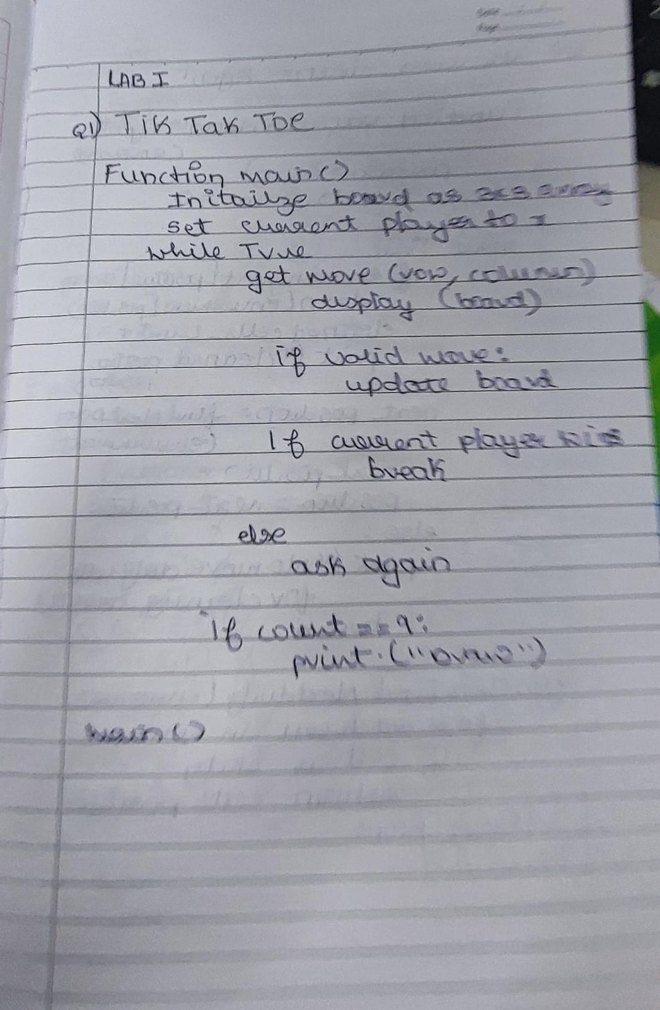 o

question 2) vaccum cleaner

output -

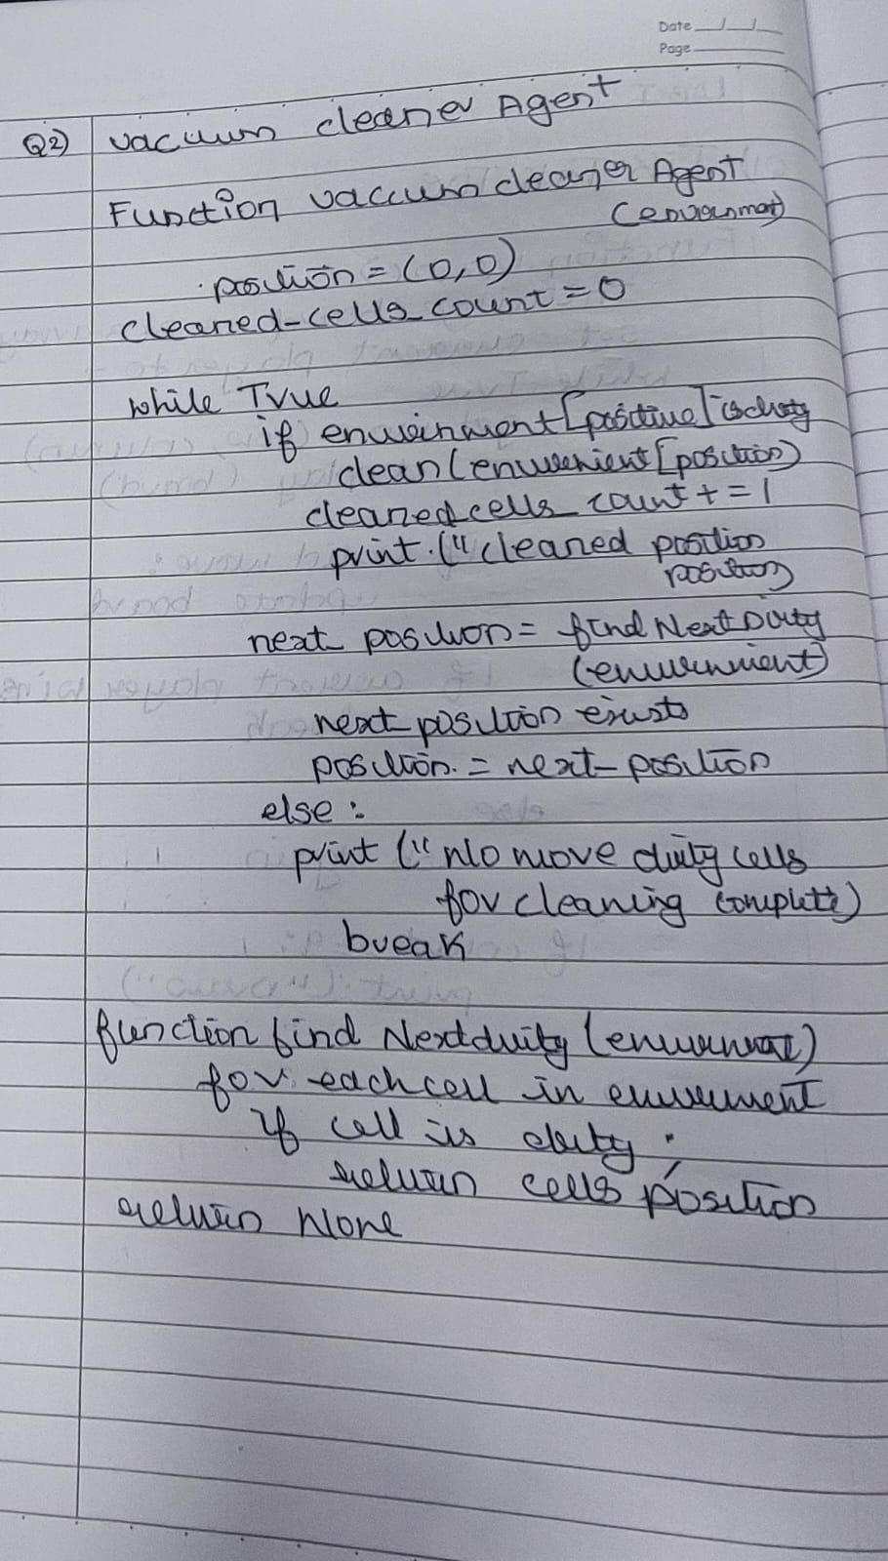

utput -